Process Design Document (PDD)

Accounts Payable Invoice Processing

Document History
[PENDING: Fill in this document's version history (date, version, author, organization, role, comments).]
Date | Version | Role | Name | Organization (Dept.) | Function | Comments

Document Approval Flow
[PENDING: Define the document approval flow (version, role, name, organization, signature and date).]
Version | Flow | Role | Name | Organization (Dept.) | Signature and Date:

Table of Contents

I. Introduction
I.1 Purpose of the Document
I.2 Objectives
I.3 Key Contacts
I.4 Minimum Prerequisites for Automation

II. As-Is Process Description
II.1 Process Overview
II.2 Applications Used in the Process
II.3 As-Is Process Map
II.4 Detailed As-Is Process Steps
II.5 Input Data Description

III. To-Be Process Description
III.1 To-Be Detailed Process Map
III.2 Parallel Initiatives / Overlap (if applicable)
III.3 In Scope for RPA
III.4 Out of Scope for RPA
III.5 Business Exceptions Handling
III.6 Application Error and Exception Handling
III.7 Reporting
III.8 Transaction Definition
III.9 Restart, Recovery and Reprocessing
III.10 Human-in-the-Loop Interventions
III.11 Business Rules Library

IV. Technical Requirements and Infrastructure
IV.1 Environments
IV.2 Robot Accounts and Credentials
IV.3 Machine and Application Requirements
IV.4 Scheduling and Execution Windows
IV.5 Application Change Management

V. Data Protection and Compliance
V.1 Personal and Sensitive Data Processed
V.2 Data Handling Requirements
V.3 Audit Trail

VI. Testing and Acceptance Criteria
VI.1 Test Data
VI.2 Test Scenarios
VI.3 Acceptance Criteria
VI.4 User Acceptance Sign-off

VII. Transition to Production and Support
VII.1 Hypercare
VII.2 Escalation Matrix
VII.3 Benefit Measurement Baseline

VIII. Assumptions, Constraints and Risks
VIII.1 Assumptions
VIII.2 Constraints
VIII.3 Risks

IX. Other Observations
X. Additional Sources of Process Documentation

Introduction

I.1 Purpose of the Document
Reading convention for this document: text in italics is interpretation derived from the discovery (basis: inferred), to be confirmed during validation with the process owner. [PENDING] marks in yellow indicate information that cannot be obtained from the recording and awaits the client's answer. The To-Be design is a proposal from the system, not a decision already made.

The Process Definition Document outlines the business process chosen for automation using Robotic Process Automation (RPA) technology.
The document describes the sequence of steps performed as part of the business process, the conditions and rules of the process prior to automation and how they are envisioned to work after automating it, partly or entirely. This specifications document serves as a base for developers, providing them the details required for applying robotic automation to the selected business process.

The process ensures that every supplier invoice is validated against its purchase order and posted to the correct payment batch, so that suppliers are paid accurately and on time.
Timely and accurate supplier payment supports contractual payment terms and a clean month-end close.

I.2 Objectives

The business objectives and benefits expected by the Business Process Owner after automation of the selected business process are:
Reduce manual keying and validation effort, cut invoice-entry errors, and shorten the time from invoice receipt to payment.
[PENDING: Confirm the objectives described and complement them with quantitative targets (reduction of time, error, cost).]

I.3 Key Contacts
[PENDING: Who are the key contacts of the process (Process Owner, SMEs, IT) with role, name and e-mail?]

The specifications document includes concise and complete requirements of the business process and it is built based on the inputs provided by the process Subject Matter Expert (SME)/ Process Owner.
The Process Owner is expected to review it and provide signoff for accuracy and completion of the steps, context, impact and complete set of process exceptions. The names have to be included in the table below.
Role | Name | Contact details  (email, phone number) | Notes

I.4 Minimum Prerequisites for Automation

An ERP account with invoice-entry rights, access to the AP shared mailbox, and access to the vendor portal.
[PENDING: Which minimum prerequisites are already met (test data, access and user accounts, credentials, dependencies with other projects)?]

As-Is Process Description

II.1 Process Overview

General information about the process selected for RPA prior to automation.
# | Item | Description
1 | Process full name | Accounts Payable Invoice Processing
2 | Process Area | Finance
3 | Department | Accounts Payable
4 | Process short description  (operation, activity, outcome) | Registering, validating and posting supplier invoices in the ERP, from receipt in the shared mailbox to the approved payment batch.
5 | Role(s) required for performing the process | Accounts Payable Analyst, AP Team Lead
6 | Process schedule and frequency | Monthly, aligned to the supplier payment cycle (evidence: batch named 'AP_batch_2026-03' and the analyst's mention of a monthly run) [CONFIRM]
7 | # of items processes /reference period | [PENDING: How many items are processed per day or per month (reference period)?]
8 | Average handling time per item | [PENDING: What is the average manual handling time per item?]
9 | Peak period (s) | [PENDING: Is there a peak period? When does it occur?]
10 | Transaction Volume During Peak period | [PENDING: What is the transaction volume during the peak period?]
11 | Total # of FTEs supporting this activity | [PENDING: How many people (FTEs) sustain this process today?]
12 | Expected increase of volume in the next reference period | [PENDING: Is there an expected increase in volume over the coming months? By how much?]
13 | Level of exception rate | [PENDING: What is the expected exception rate/level in the process?]
14 | Input data | Supplier invoice arriving in the AP shared mailbox
15 | Output data | Approved invoice posted to a payment batch in the ERP
*Add more rows to the table to include relevant data for the automation process. No fields should be left empty. Use “n/a” for the items that don`t apply to the selected business process.

II.2. Applications Used in the Process

The table includes a comprehensive list all the applications that are used as part of the process automated, at various steps in the flow.
# | Application name & version | System  Language | Thin/Thick  Client | Environment/  Access method | Comments
1 | Ledgerly ERP 8.2 | English | Desktop | Single sign-on | System of record for invoices and payments (first seen 00:00:41)
2 | MailDesk | English | Desktop | Corporate account | Email client, AP shared mailbox (first seen 00:00:12)
3 | SupplierHub Portal | English | Web | Vendor portal login | Purchase order and delivery lookup (first seen 00:03:20)
4 | Reconciliation Workbook | English | Desktop | Network folder | Spreadsheet used to tie invoices to the payment batch (first seen 00:11:05)
*Add more rows to the table to include the complete list of applications.

II.3 As-Is Process Map
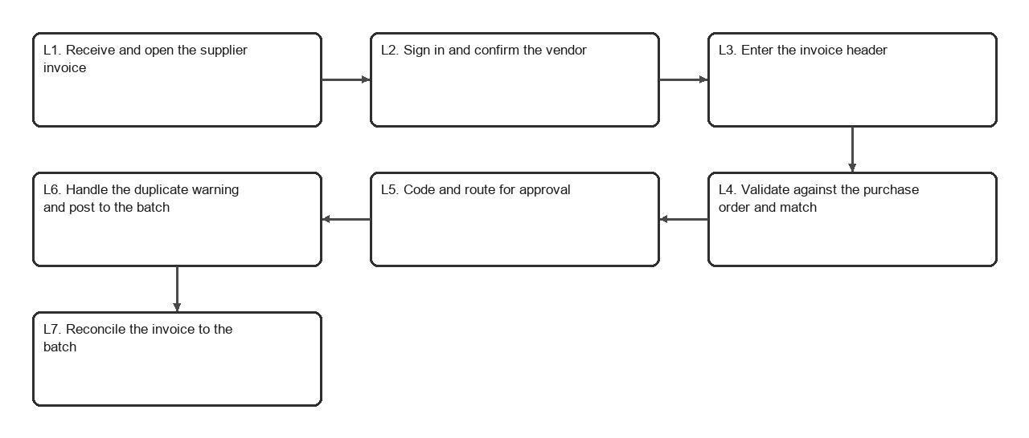
High-level As-Is map, generated from the observed logical steps
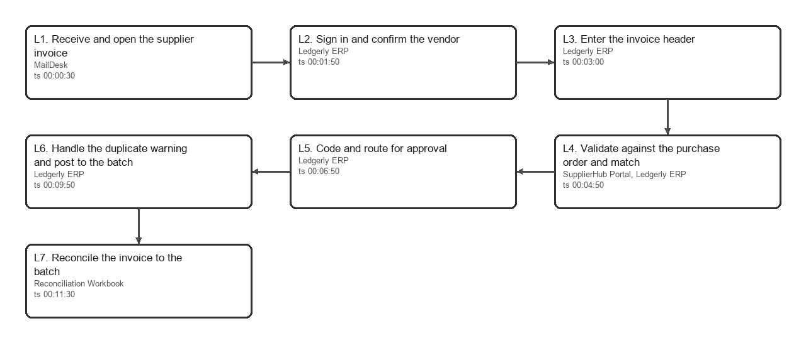
Detailed As-Is map, generated from the observed logical steps

High Level As-Is Process Map:
This chapter depicts the As Is business process at a High Level to enable developers to have a high-level understanding of the current process.

Detailed As-Is Process Map:

II.4 Detailed As-Is Process Steps

This chapter depicts the As-Is business process in detail to enable the Developer to build the automated process.
 | Detailed As-Is Process Steps
Step | Input | Description | Details (Screen/ Document/ Video recording Index) | Exception Handling | Possible Actions | Business Rules Library Index
L1 | Invoice PDF attachment | Receive and open the supplier invoice. The analyst opens the oldest invoice email in the AP shared mailbox and downloads the invoice PDF. | MailDesk [ts 00:00:30, basis observed, conf. high]
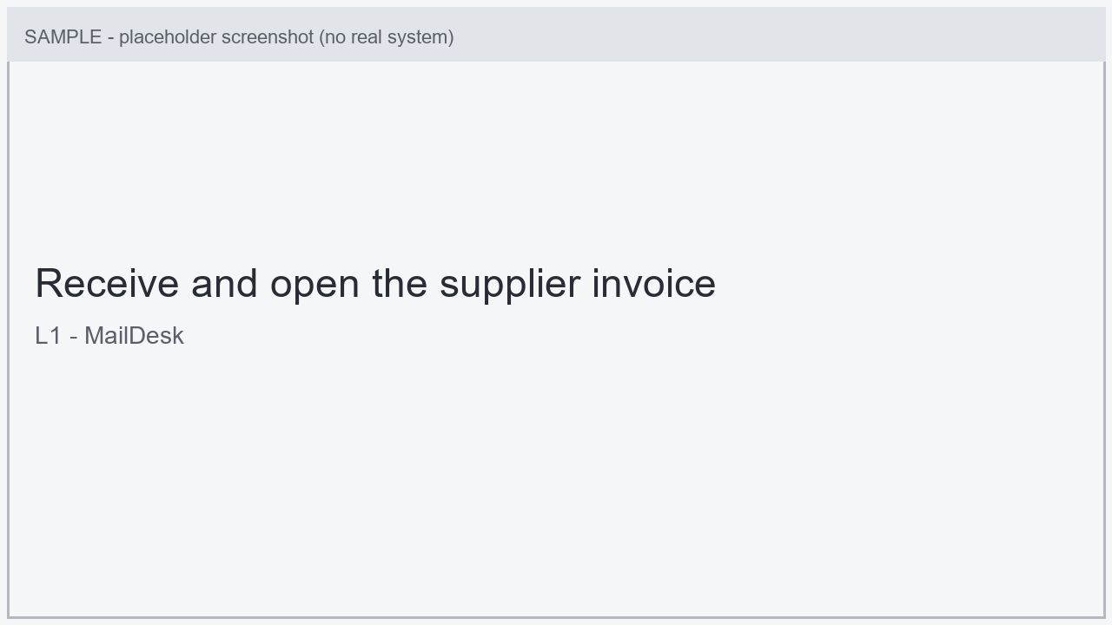
Screen at 00:00:30
L2 | Vendor ID, vendor status | Sign in and confirm the vendor. The analyst signs in to the ERP and reads the vendor record to confirm it is active before any entry. Decisao humana: Proceed only if the vendor is Active | Ledgerly ERP [ts 00:01:50, basis observed, conf. high] |  |  | BR1
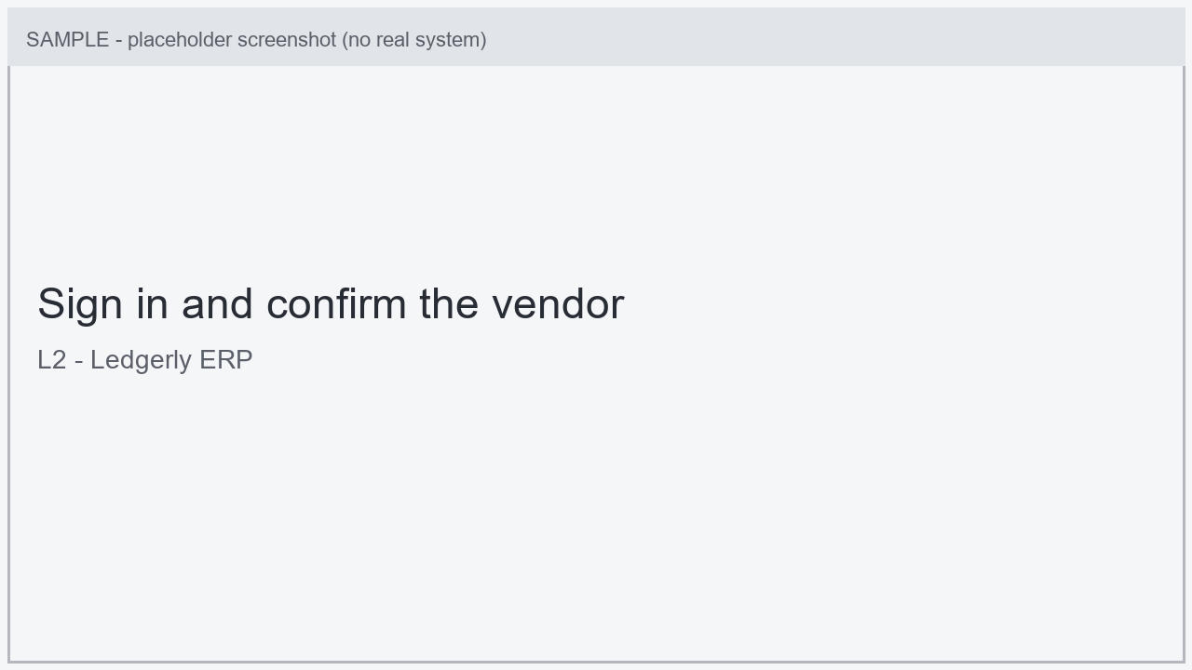
Screen at 00:01:50
L3 | Invoice No., date, gross amount | Enter the invoice header. The analyst keys the invoice number, date and gross amount into the ERP invoice-entry screen. | Ledgerly ERP [ts 00:03:00, basis observed, conf. high] |  |  | BR1
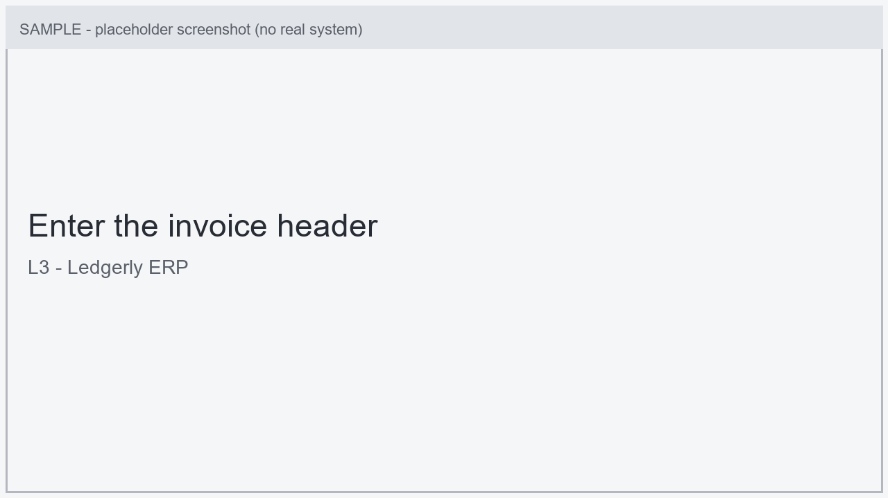
Screen at 00:03:00
L4 | PO number, PO amount, match result | Validate against the purchase order and match. The analyst reads the linked purchase order on the vendor portal and runs the three-way match in the ERP. Decisao humana: Continue only if the match passes | SupplierHub Portal, Ledgerly ERP [ts 00:04:50, basis observed, conf. high] |  |  | BR3
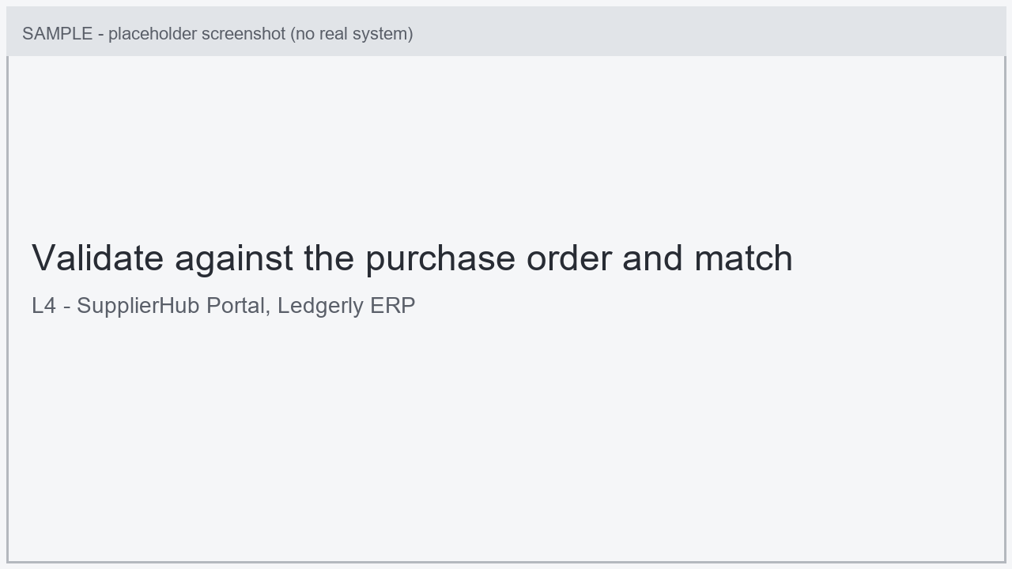
Screen at 00:04:50
L5 | GL account, approver | Code and route for approval. The analyst assigns the GL account and routes the invoice to the AP Team Lead for approval above the threshold. Decisao humana: Requires human approval above threshold | Ledgerly ERP [ts 00:06:50, basis observed, conf. high] |  |  | BR3
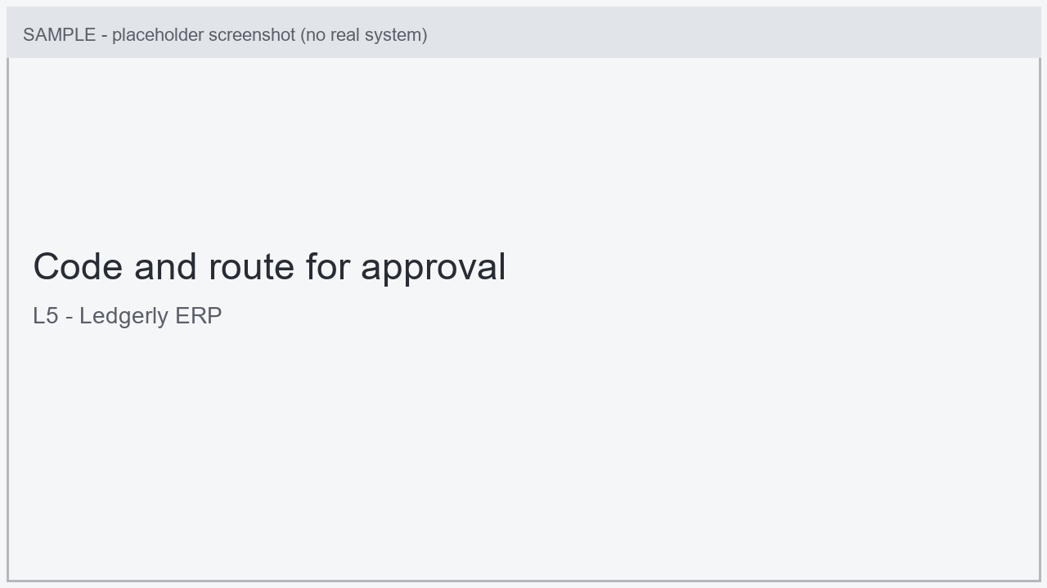
Screen at 00:06:50
L6 | Batch ID | Handle the duplicate warning and post to the batch. The analyst clears the possible-duplicate warning and posts the approved invoice into the current payment batch. | Ledgerly ERP [ts 00:09:50, basis observed, conf. high] | BE1
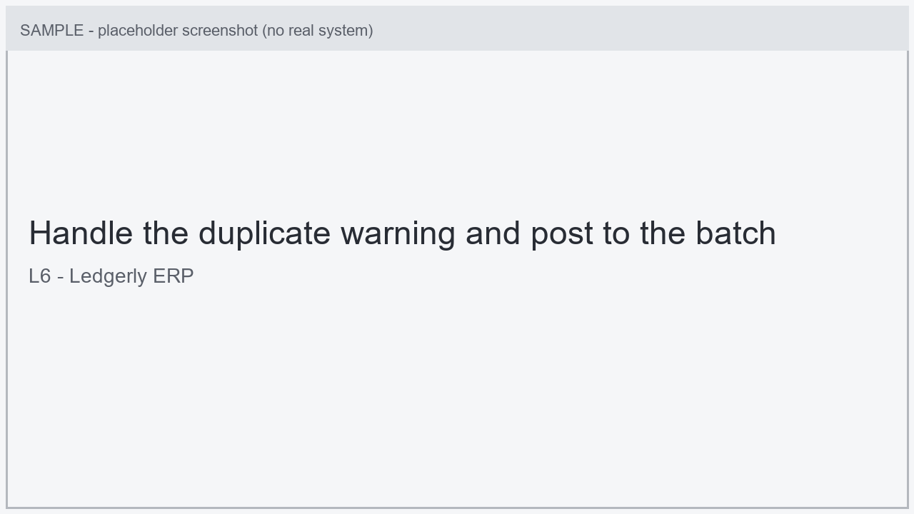
Screen at 00:09:50
L7 | Invoice No., amount | Reconcile the invoice to the batch. The analyst records the invoice number and amount in the reconciliation workbook to tie it to the payment batch. | Reconciliation Workbook [ts 00:11:30, basis observed, conf. medium]
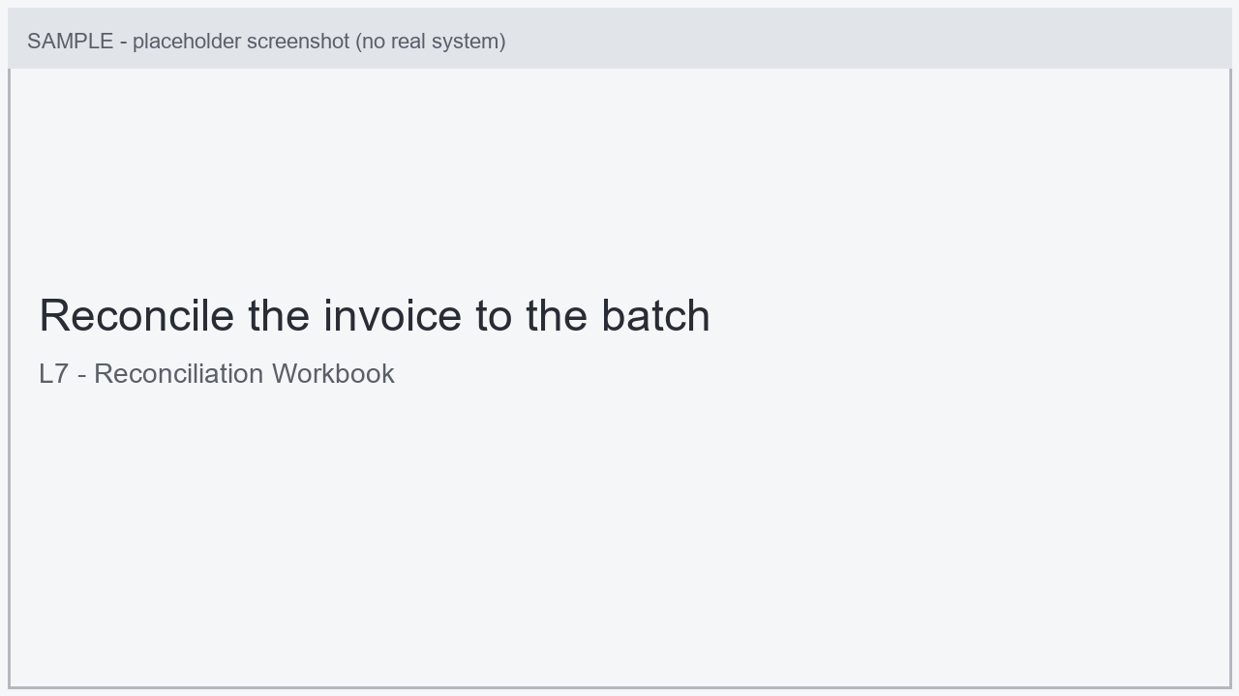
Screen at 00:11:30
See doc attached

II.5 Input Data Description

Step | Sample  (Print-screen) | Input type | Location | Inputs are standard? (Yes/ NO) | Inputs are structured? | Data to be used from
L1 | n/a | Supplier invoice (PDF) | AP shared mailbox | No | No | Invoice No., Invoice date, Gross amount, Vendor
L4 | n/a | Purchase order | SupplierHub Portal | Yes | Yes | PO number, PO amount, Quantities
* Inputs are standard if the content is positioned in the same place even if the input types are different.
E.g. a process that uses at each transaction the same template, so fields to be extracted are always fixed..
Inputs are structured if it is machine readable and digital. Scanned PDF Images/ Free flow texts in Emails are unstructured inputs

To-Be Process Description

This chapter highlights the expected design of the business process after automation.

III.1 To-Be Detailed Process Map
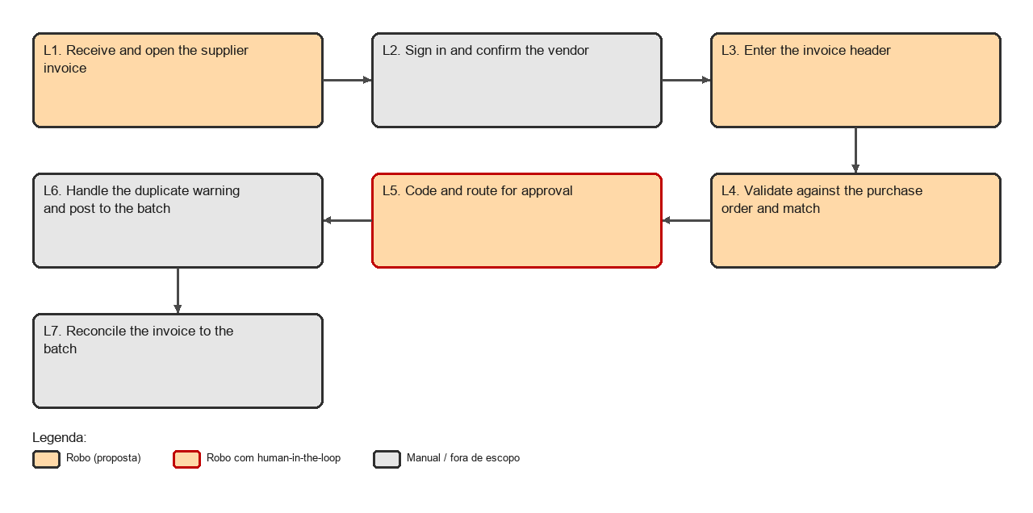
Proposed To-Be map: orange marks a step that is a robot candidate, a red border marks human-in-the-loop, grey stays manual or out of scope (proposal to validate)
SYSTEM PROPOSAL, TO VALIDATE: the To-Be design below was generated from the discovery and must be validated with the process owner.
A robot could pick up invoices from the shared mailbox, read the header fields, confirm the vendor and run the three-way match, then post matched invoices to the payment batch, leaving approval and exception handling to the analyst.
Automation candidates (proposal):
L1 (Receive and open the supplier invoice): Reading the mailbox and downloading the attachment is repetitive and rule-based. [human in the loop: no]
L3 (Enter the invoice header): Keying the invoice header from a structured document is a strong automation candidate. [human in the loop: no]
L4 (Validate against the purchase order and match): The PO lookup and three-way match follow deterministic rules. [human in the loop: no]
L5 (Code and route for approval): GL coding can be automated, but the approval above threshold must stay with the AP Team Lead. [human in the loop: yes]
Suggested items out of automation scope (proposal):
Amount-mismatch resolution requires judgement and a conversation with the buyer; keep it manual.
Reconciliation review at month-end is better left to the analyst until volumes are confirmed.
[PENDING: Validate the system-generated To-Be proposal with the process owner (automated vs manual steps, suggested improvements).]

Highlight Bot interventions/ to-be automated steps with different legend/ icon (orange)
*Mention below if process improvements were performed on the To-Be design and detail them

III.2 Parallel Initiatives/ Overlap (if applicable)
[PENDING: Are there parallel initiatives or planned system changes that impact this automation?]

This chapter captures the proposed Business, Process & System changes in near future and its impact
S. No | Initiative Name | Process Step(s) where it is identified | Impact on current automation request? How? | Expected Completion Date | Contact person for more details
 | n/a

III.3 In Scope for RPA
[PENDING: Which steps of the process are within the automation scope?]

The activities in scope of RPA, are listed here:

III.4 Out of Scope for RPA
[PENDING: Which activities are out of the automation scope and why?]

The activities OUT of scope of RPA, are listed here:

Sub-process  (if case) | Activity (step) | Reasons for Out of Scope* | Impact on the To-Be | Possible measures to be taken into consideration for future automation
1.1
*Add more rows to the table to reflect the complete documentation provided to support the RPA process.

III.5 Business Exceptions Handling

The Business Process Owner and Business Analysts are expected to document below all the business exceptions identified in the automation process. These can be classified as:
Known | Unknown
Previously encountered. A scenario is defined with clear actions and workarounds for each case. | New situation never encountered before. It can be caused by external factors. Cannot be predicted with precision, however if it occurs, it must be communicated to an authorized person for evaluation.

Known Exceptions
The table below reflects all the business process exceptions captured during the process evaluation and documentation. These are known exceptions, met in practice before. For each of these exceptions, define a corresponding expected action that the robot should complete if it encounters the exception.
BE # | Exception name | Step | Parameters | Action to be taken
BE1 | Possible duplicate invoice | L6 | ERP flags an invoice number close to an existing one [observed] | Analyst compares the numbers and dismisses the warning when they differ

Unknown Exceptions
For all the other unanticipated or unknown business (process) exceptions, the robot should:

III.6 Application Error and Exception Handling
[PENDING: No application error was observed in the video. Which system errors/messages can occur and what is the expected action?]
A comprehensive list of all errors, warnings or notifications should be consolidated here with the description and action to be taken, for each, by the Robot.
Errors identified in the automation process can be classified as:
Area | Known | Unknown
Technology/  Applications | Experienced previously, action plan or workaround available for it. | New situation never encountered before or may happened independent of the applications used in the process.

Known Errors or Exceptions
The table below reflects all the errors identifiable in the process evaluation and documentation.
For each of these errors or exceptions, define a corresponding expected action that the robot should complete if it is encountered.
# | Error name | Step | Parameters | Action to be taken

Unknown Errors and Exceptions
For all the other unanticipated or unknown application exceptions/errors, the robot should:

III.7 Reporting
[PENDING: Which reports are expected (type, frequency, details, monitoring tool)?]

# | Report type | Update frequency | Details | Monitoring Tool to visualize the data
1 | Process logs | Daily | How many times was this process run since the beginning of the month and what was the average run duration? | Kibana
2 | Process logs | Monthly | How many robots worked on this process per each month? | Csv file posted daily on sharedrive
3 | Transaction logs | Daily | How many transactions were run by this process since the beginning of the month and what was the average transaction duration? | Kibana
4 | Error logs | Daily | Average number of errors by type per day | Kibana
5 | Error logs | Daily | All errors per month grouped by type | Csv file posted daily on drive
* For complex reporting requirements, include them into a separate document and attach it to the present documentation

III.8 Transaction Definition
A transaction is the smallest unit of work that the robot processes from start to finish. Defining it precisely is a prerequisite for queue design, restart logic and duplicate prevention. This section must be completed before development starts.
# | Item | Description
1 | Transaction definition | [PENDING: What is the definition of a transaction (smallest unit of work processed end to end)?]
2 | Unique transaction key | [PENDING: What is the unique key that identifies each transaction? (suggest and validate)]
3 | Duplicate detection rule | [PENDING: What is the duplicate-detection rule?]
4 | Transaction source | [PENDING: What is the source of the transactions (mailbox, file, queue)?]
5 | Processing order and priority | [PENDING: What is the processing order and priority of the transactions?]
6 | Maximum retry attempts per transaction | [PENDING: What is the maximum number of retries per transaction?]
7 | Definition of a successfully completed transaction | [PENDING: What defines a successfully completed transaction?]
8 | Definition of a failed transaction | [PENDING: What defines a failed transaction?]
9 | Expected daily volume of transactions | [PENDING: What is the expected daily volume of transactions?]
*No fields should be left empty. Use "n/a" for the items that don`t apply to the selected business process.

III.9 Restart, Recovery and Reprocessing
[PENDING: What is the expected restart, recovery and reprocessing behaviour in case of interruption?]
[PENDING: Is the process idempotent (can the same transaction be submitted twice with no side effect)?]
This section documents the expected system state and the recovery behaviour when the robot is interrupted mid transaction. The objective is to guarantee that no transaction is processed twice and that no transaction is silently lost.
# | Interruption scenario | System state after interruption | Expected robot behaviour on restart | Manual action required
1 | Robot stops after entering data, before saving in the ERP | No record created | Reprocess the transaction from the beginning | None
2 | Robot stops after saving in the ERP, before sending the confirmation email | Sales Order created, client not notified | Detect the existing Sales Order, skip creation and resume from the notification step | None
3 | Robot stops during a batch already partially processed | Some transactions completed, some pending | Resume from the first pending transaction based on the queue status | None
4 | Full re-run of a batch requested by the business | All transactions already completed | Not allowed without prior validation | Business approval required before re-run
*Add more rows to the table to cover every interruption point identified in the process.
Is the process idempotent (can the same transaction be submitted twice without side effects)? If not, describe the compensating action required to revert a partially processed transaction:
# | Step | Side effect if repeated | Compensating action
1

III.10 Human-in-the-Loop Interventions
Steps where the process cannot be fully unattended and requires a human decision, validation or approval before the robot continues.
# | Step | Trigger for human intervention | Role responsible | Input expected back from the human | Expected response time
1 | L5 (Code and route for approval) | Accounts Payable Analyst hands off to AP Team Lead via ERP approval workflow | AP Team Lead | Invoice approved for posting | [PENDING]
*Specify the channel used for the intervention (email, form, Action Center, ticket) and what the robot should do if no response is received within the expected time.

III.11 Business Rules Library
Consolidated list of the business rules applied during the process, referenced by the "Business Rules Library Index" column of the Detailed As-Is Process Steps table (section II.4). Each rule must have an identified source and owner so that it can be revalidated when the business changes.
BR # | Rule description | Applies to step(s) | Source (policy, SME, system behaviour) | Rule owner | Last validated on
BR1 | An invoice is only entered if the vendor is Active in the ERP. | L2, L3 | observed on the vendor lookup screen [observed]
BR3 | The three-way match (invoice, PO, goods receipt) must pass before GL coding. | L4, L5 | observed on the match screen [observed]
*Add more rows to the table to include the complete set of business rules identified during the process documentation.

Technical Requirements and Infrastructure
[PENDING: Which environments are available (dev, test, prod) and how are they accessed?]
[PENDING: How will the robot's accounts and credentials be provisioned per application?]
[PENDING: What are the machine and application requirements for execution?]
[PENDING: What is the scheduling and execution window of the robot?]
[PENDING: How are interface changes in the used applications managed?]
This chapter consolidates the technical prerequisites that must be confirmed before development starts. Any item left open here becomes a project risk.

IV.1 Environments
Environment | Available (Yes/No) | Access method | Data used (real / masked / synthetic) | Environment owner | Notes
Development | Yes | VPN + named user | Synthetic | IT Infrastructure
Test / QA | Yes | VPN + named user | Masked | IT Infrastructure
Production | Yes | VPN + robot account | Real | IT Infrastructure
*If no test environment is available, describe how development and testing will be performed and which mitigation applies.

IV.2 Robot Accounts and Credentials
# | Application | Account type (named / generic) | Account owner | Credential storage | Password expiry policy | Status (requested / created)
1 | ERP | Generic (robot) | IT Security | Credential vault | 90 days | Requested
*Credentials must never be stored in the automation code or in plain text files. Password rotation must be coordinated with the RPA team to avoid unplanned failures.

IV.3 Machine and Application Requirements
# | Item | Description
1 | Execution machine | Virtual machine / physical desktop / VDI
2 | Operating system and version | Windows 10 Enterprise 22H2
3 | Screen resolution | 1920 x 1080
4 | Application versions | Exact version of each application listed in section II.2
5 | Regional settings | Date format, decimal separator, interface language, time zone
6 | Additional software dependencies | Drivers, add-ins, certificates, fonts
7 | Network restrictions | VPN, proxy, firewall rules, allowed domains
8 | Security policies affecting execution | Antivirus, GPO, screen lock, session timeout
9 | RPA platform licensing | Number and type of runner licenses available for this process

IV.4 Scheduling and Execution Windows
# | Item | Description
1 | Trigger type | Time based / event based / queue based / manual
2 | Execution window | Monday to Friday, 07:00 to 19:00
3 | Blackout periods | System maintenance windows when the robot must not run
4 | Expected duration per run
5 | Number of robots running concurrently
6 | SLA for completion | All transactions received on day D processed by 18:00 of day D
7 | Behaviour when the SLA cannot be met | Notify the Process Owner and continue on the next execution window

IV.5 Application Change Management
Interface or behaviour changes in the applications used by the process are the most frequent cause of automation failure. This section defines who informs the RPA team in advance.
# | Application | Change notification owner | Minimum notification lead time | Impact assessment responsible
1 | ERP | IT Applications | 10 business days | RPA Solution Architect

Data Protection and Compliance
This chapter documents the personal and sensitive data handled by the automation and the controls applied to it. It must be reviewed together with the data protection officer or the equivalent function before go-live.

V.1 Personal and Sensitive Data Processed
# | Data field | Data subject | Sensitivity | Purpose of processing | Legal basis | Retention period
Data processed by the process
1 | Approver name (J. Rivera) (screen Approval routing, ts 00:06:40) |  | personal
2 | Analyst account name (ap.analyst) (screen ERP login, ts 00:00:55) |  | personal
Data observed in the recording (not processed by the process, listed for exposure assessment)
3 | Customer name in a background email preview (screen Mailbox preview pane, ts 00:07:20) |  | personal
*Add more rows to the table to include every personal or sensitive data field handled by the robot, including data present in screenshots and logs.

V.2 Data Handling Requirements
[PENDING: Which data-handling requirements apply (storage, transit, masking, retention)?]
# | Requirement | Applies (Yes/No) | Description
1 | Masking of personal data in execution logs | Yes | Client identifiers must not be written in clear text in the logs
2 | Screenshots captured on error | Yes | Screenshots may contain personal data. Define storage location and retention
3 | Storage location of processed files |  | Path, access control and retention
4 | Cross border data transfer |  | Identify if data leaves the country of origin
5 | Secure deletion of temporary files |  | Files created during execution must be removed at the end of the run
6 | Access to the robot output |  | Who can access the generated files and reports

V.3 Audit Trail
[PENDING: Which events must be logged for audit, for how long and who can access them?]
# | Event to be logged | Logged (Yes/No) | Retention period | Accessible by
1 | Transaction started and completed | Yes | 12 months | Process Owner, RPA team
2 | Business exception raised | Yes | 12 months | Process Owner, RPA team
3 | Human intervention and decision taken | Yes | 12 months | Process Owner, Audit
4 | Credential retrieval from the vault | Yes | 12 months | IT Security

Testing and Acceptance Criteria
[PENDING: Which test data covers the happy path and each known exception?]
[PENDING: Which test scenarios must be run and what is the expected result?]
[PENDING: What are the acceptance criteria and how will they be measured?]
[PENDING: Who signs off the user acceptance (UAT)?]
This chapter defines how the automation will be validated and what has to be true for the business to accept the delivery. Acceptance criteria must be agreed before development starts.

VI.1 Test Data
# | Scenario covered | Data source | Volume required | Provided by | Available on
1 | Happy path | Masked production extract | 20 transactions | Process SME
*Test data must cover the happy path, every known business exception and every known application error documented in sections III.5 and III.6.

VI.2 Test Scenarios
# | Scenario | Type (happy path / business exception / application error) | Steps covered | Expected result | Priority
1 | Purchase Order processed successfully | Happy path | 1-10 | Sales Order generated and confirmation sent | High
2 | Product out of stock | Business exception | 6 | Error ignored, data saved, transaction completed | High
3 | ERP unavailable | Application error | Any | Retry 3 times, then notify and mark the transaction as failed | High

VI.3 Acceptance Criteria
# | Criterion | Measurement method | Target | Verified by
1 | Functional accuracy | Comparison of robot output against manual output for the UAT sample | 100% of the sample matching | Process SME
2 | Successful transaction rate | Execution logs over the UAT period | At least 95% of transactions completed without manual intervention | Process Owner
3 | Average handling time per transaction | Execution logs |  | RPA team
4 | All known exceptions handled as documented | Test scenario execution | All scenarios passed | Process SME

VI.4 User Acceptance Sign-off
Role | Name | Responsibility | Date | Signature
Process SME |  | Confirms functional accuracy of the automation
Process Owner |  | Confirms the acceptance criteria were met
RPA Solution Architect |  | Confirms technical readiness for production

Transition to Production and Support
[PENDING: How will hypercare work (duration, owners, ticket classification)?]
[PENDING: What is the escalation matrix (level, trigger, owner, response time)?]
[PENDING: What is the baseline for benefit measurement before go-live?]

VII.1 Hypercare
# | Item | Description
1 | Hypercare duration | 4 weeks after go-live
2 | Coverage hours | Monday to Friday, 09:00 to 18:00
3 | Team responsible during hypercare | RPA development team
4 | Entry criteria | UAT signed off and production access granted
5 | Exit criteria | No critical incidents for 10 consecutive business days
6 | Handover target after hypercare | Support team / AMS
Classification of requests received during and after hypercare:
Type | Definition | Treatment
Defect | The automation does not behave as documented in this PDD | Corrected by the development team at no additional cost
Change request | The automation behaves as documented, but the business requires different behaviour | Estimated and approved separately as additional scope
Environment incident | Failure caused by the application, network or infrastructure | Escalated to the responsible IT team

VII.2 Escalation Matrix
Level | Trigger | Responsible | Contact details | Expected response time
1 | Transaction failure above the expected exception rate | RPA support team |  | 4 business hours
2 | Process stopped for more than one execution window | RPA Solution Architect |  | 2 business hours
3 | Business impact on client delivery | Process Owner |  | 1 business hour

VII.3 Benefit Measurement Baseline
Baseline measured before automation, used to demonstrate the benefit after go-live. Without a measured baseline the expected benefits stated in section I.2 cannot be verified.
# | Metric | Baseline before automation | Measurement method | Target after automation | Measurement date
1 | Average handling time per transaction |  | Time study with the operations team
2 | FTE effort allocated to the process |  | Operations capacity plan
3 | Error rate |  | Quality control sample
4 | Processing lead time per transaction |  | System timestamps

Assumptions, Constraints and Risks
[PENDING: Which assumptions were made and what is the impact if they do not hold?]
[PENDING: Which constraints (technical or business) limit the solution?]
[PENDING: Which risks exist (probability, impact, mitigation, owner)?]

VIII.1 Assumptions
# | Assumption | Impact if the assumption is not valid | Owner

VIII.2 Constraints
# | Constraint | Type (technical / business / legal / licensing) | Impact on the solution design

VIII.3 Risks
# | Risk | Probability (H/M/L) | Impact (H/M/L) | Mitigation | Owner
1 | Test environment not available on time | M | H | Escalate to IT Infrastructure at project kick-off and agree a delivery date | Project Manager

Other Observations

Include below any other relevant observations you consider needed to be documented here.
Example: Specific Business monitoring requirements (audit and reporting) etc.

Additional Sources of Process Documentation

If there is additional material created to support the process automation please mention it here, along with the supported documentation provided.
Additional Process Documentation
Video Recording of the process [Optional] | Insert link to the video recording | Insert any relevant comments
Standard Operating Procedure (s)  (Optional) |  | Insert any relevant comments
Business Logic Translation Table  (Optional) | Insert link to Business Logic Translation Table | Insert any relevant comments
Other documentation  (Optional) | Insert link to any other relevant process documentation (L4, L5 process description, fields mapping files etc.) | Insert any relevant comments
*Add more rows to the table to reflect the complete documentation provided to support the RPA process

Annex A. Traceability: logical steps and observed gestures
Step | Name | Raw gestures (ids) | Time range in the video
L1 | Receive and open the supplier invoice | 1 | 00:00:10 to 00:00:35
L2 | Sign in and confirm the vendor | 2, 3 | 00:00:36 to 00:02:05
L3 | Enter the invoice header | 4 | 00:02:06 to 00:03:19
L4 | Validate against the purchase order and match | 5, 6 | 00:03:20 to 00:05:40
L5 | Code and route for approval | 7, 8, 9 | 00:05:41 to 00:07:45
L6 | Handle the duplicate warning and post to the batch | 10, 12 | 00:07:46 to 00:10:40
L7 | Reconcile the invoice to the batch | 13 | 00:10:41 to 00:12:00

Annex B. Observed gestures not included in the process
Gesture | Timestamp | Observed action | Discard reason
11 | 00:08:31 | Accidental window switch | accidental window switch to an unrelated browser tab, not part of the process

